1. **Program to Print all non-Prime Numbers in an Interval**

print("Chandhu , 21MCA016")  
  
"""Program to Print all non-Prime Numbers in an Interval"""  
n1=int(input("Enter the fist number : "))  
n2=int(input("Enter the last number : "))  
for i in range(n1,n2):  
 for j in range(2,i):  
 if i % j == 0 :  
 print(i)  
 break

**output:**

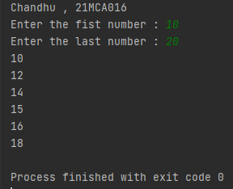

1. **Program to print the first N Fibonacci numbers.**

print("chandhu , 21MCA016")  
  
"""Program to print the first N Fibonacci numbers."""  
n=int(input("Enter the limit : "))  
a=0  
b=1  
print("Fibonacci numbers are: ")  
print(a," ",end=" ")  
print(b," ",end=" ")  
for i in range(1,n):  
 c=a+b  
 a=b  
 b=c  
 print(c," ",end=" ")

**output:**

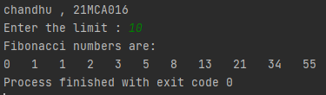

**3. Given sides of a triangle, write a program to check whether given triangle is an**

**isosceles, equilateral or scalene.**

print("chandhu , 21MCA016")  
  
"""Given sides of a triangle, write a program to check whether given triangle is an  
isosceles, equilateral or scalene."""  
  
n1 = int(input("enter the side1:"))  
n2 = int(input("enter the side2:"))  
n3 = int(input("enter the side3:"))  
if n1 == n2 and n1 == n3 and n2 == n3:  
 print("triangle is equilateral")  
elif((n1==n2!=n3)|(n1!=n2==n3)|(n1==n3!=n2)):  
 print("triangle is isosceless")  
else:  
 print("triangle is scalene")

**Output:**

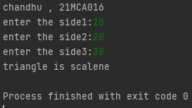

1. **Program to check whether given pair of number is coprime**
2. print("chandhu , 21MCA016")  
     
   """Program to check whether given pair of number is coprime"""  
     
   import math  
   a=int(input("Enter a number : "))  
   b=int(input("Enter another number : "))  
   if math.gcd(a,b) == 1:  
    print("Given numbers are Co-prime")  
   else:  
    print("Given numbers are not Co-prime ")

**Output:**

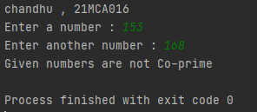

**6. Program to check whether a given number is perfect number or not(sum of factors**

**=number)**

print("chandhu , 21MCA016")  
  
"""Program to check whether a given number is perfect number or not (sum of factors  
=number)"""  
  
a=int(input("Enter a number : "))  
b=0  
for i in range(1,a):  
 if a%i == 0:  
 b=b+i  
if a == b:  
 print("The number is perfect number ")  
else:  
 print("The number is not perfect ")

**Output:**

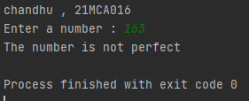

**7. Program to display amstrong numbers upto 1000**

print("chandhu , 21MCA016")  
  
"""Program to display amstrong numbers upto 1000"""  
n=1000  
print("amstrong numbers are")  
for i in range(0,n):  
 s = [int(a) for a in str(i)]  
 l = len(s)  
 t = [c**l for c in s]  
 r = sum(t)  
 if(i==r):  
 print(r)

**Output:**

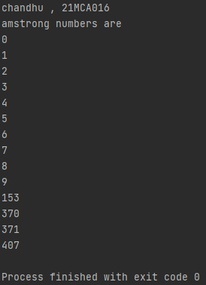

**8. Store and display the days of a week as a List, Tuple, Dictionary, Set. Also**

**demonstrate different ways to store values in each of them. Display its type also.**

print("chandhu , 21MCA016")  
  
"""Store and display the days of a week as a List, Tuple, Dictionary, Set. Also  
demonstrate different ways to store values in each of them. Display its type also."""  
  
list1=['Sunday','Monday','Tuesday','Wednesday','Fhursday','Friday','Saturday']  
tuples=('Sunday','Monday','Tuesday','Wednesday','Fhursday','Friday','Saturday')  
set1={'Sunday','Monday','Tuesday','Wednesday','Fhursday','Friday','Saturday'}  
dicts={'0':'Sunday','1':'Monday','2':'Tuesday','3':'Wednesday','4':'Thursday','5':'Friday','6':'Saturday'}  
  
print(list1,type(list1))  
print(tuples,type(tuples))  
print(set1,type(set1))  
print(dicts,type(dicts))

**Output**:

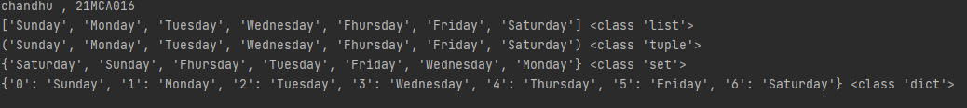

**9. Write a program to add elements of given 2 lists**

print("chandhu , 21MCA016")  
  
"""Write a program to add elements of given 2 lists"""  
  
n1=int(input("Enter the limit of 1st and 2nd list list : "))  
l1=[]  
print("Enter the 1st list elements : ")  
for i in range(0,n1):  
 x=int(input())  
 l1.append(x)  
l2 = []  
print("Enter the 2nd list elements :")  
for i in range(0, n1):  
 y = int(input())  
 l2.append(y)  
l3=[]  
for i in range(0,len(l1)):  
 l3.append(l1[i] + l2[i])  
print("First list : ",l1)  
print("Second list : ",l2)  
print("Lists after addition :",l3)

**Output:**

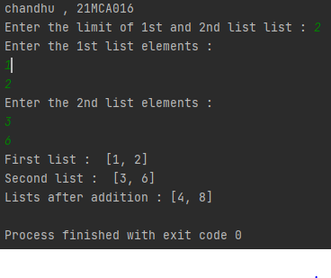

**10. Write a program to find the sum of 2 matrices using nested List.**

print("chandhu , 21MCA016")  
  
"""Write a program to find the sum of 2 matrices using nested List."""  
  
n=int(input("Enter the row size :"))  
m=int(input("Enter the coloumn size :"))  
a=[]  
b=[]  
c=[]  
print("Enter the matrix - 1 :")  
for i in range(0,n):  
 a.append([])  
 for j in range(0,m):  
 p=int(input())  
 a[i].append(p)  
print("Enter the matrix - 2 :")  
for i in range(0,n):  
 b.append([])  
 for j in range(0,m):  
 q=int(input())  
 b[i].append(q)  
c=[[0 for i in range(m)] for i in range(n)]  
for i in range(n):  
 for j in range(m):  
 c[i][j]=a[i][j]+b[i][j]  
print("Matrix-1+Matrix-2")  
for r in c:  
 print(r)

**Output:**

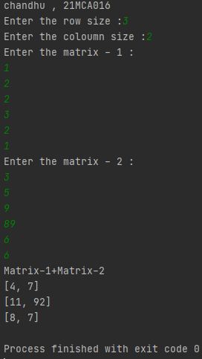

**11. Write a program to perform bubble sort on a given set of elements.**

print("chandhu , 21MCA016")  
  
"""Write a program to perform bubble sort on a given set of elements."""  
  
n=int(input("Enter the limit of list : "))  
a=[]  
print("Enter the elements of list : ")  
for i in range(n):  
 x=int(input())  
 a.append(x)  
print("Before the bubble sort the elements are : ")  
print(a)  
for i in range(n-1):  
 for j in range(n-1):  
 if (a[j]>a[j+1]):  
 temp=a[j]  
 a[j]=a[j+1]  
 a[j+1]=temp  
print("After the bubble sort the elements are : ")  
print(a)

**output:**

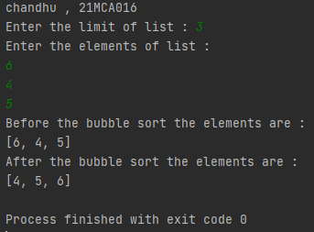

**12. Program to find the count of each vowel in a string(use dictionary)**

print("chandhu , 21MCA016")  
  
"""Program to find the count of each vowel in a string (use dictionary)"""  
  
  
vowels=[]  
vow={"a","A","e","E","i","I","o","O","u","U"}  
str=input("Enter a word : ")  
for i in str:  
 for x in vow:  
 if(i==x):  
 vowels.append(i)  
print("Vowels are")  
print(vowels)

**output:**

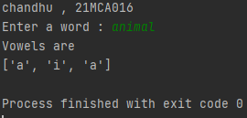

**13. Write a Python program that accept a positive number and subtract from this**

**number the sum of its digits and so on. Continues this operation until the number is**

**positive(eg: 256-&gt;2+5+6=13**

**256-13=243**

**243-9=232……..**

print("chandhu , 21MCA016")  
  
"""Write a Python program that accept a positive number and subtract from this  
number the sum of its digits and so on. Continues this operation until the number is  
positive (eg: 256-&gt;2+5+6=13  
256-13=243  
243-9=232……."""  
  
num=int(input("Enter a number : "))  
def digitsum(num):  
 sum=0  
 while num>0:  
 rem=num%10;  
 sum=sum+rem;  
 num=num//10  
 return sum  
while(num>0):  
 sum=digitsum(num)  
 print("{} - {} = {}".format(num,sum,num-sum))  
 num=num-sum

**output:**

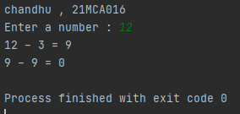

**14. Write a Python program that accepts a 10 digit mobile number, and find the digits**

**which are absent in a given mobile number**

print("chandhu , 21MCA016")  
  
"""Write a Python program that accepts a 10-digit mobile number, and find the digits  
which are absent in a given mobile number"""  
  
def absent_digits(n):  
 all_nums = set([0,1,2,3,4,5,6,7,8,9])  
 n = set([int(i) for i in n])  
 n = n.symmetric_difference(all_nums)  
 n = sorted(n)  
 return n  
  
str = input("\nPlease enter the mobile number:")  
str_set = set(str)  
print('\nThe Mobile Number is:')  
print(str_set)  
print('\nThe Missing digits ofnmMobile Number is:')  
print(absent_digits(str_set))

**output:**

